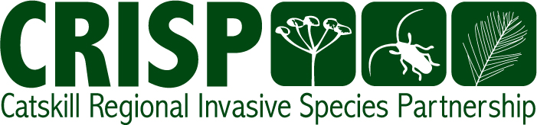

2012 Annual Report

Prepared by Molly Marquand
CRISP Coordinator
And
Whitney Hill
Catskill Invasive Species Assistant

CRISP is the Catskill Partnership for Regional Invasive Species
Management (PRISM) and is hosted by The Catskill Center for
Conservation and Development, Arkville, NY

Mission

To promote education, prevention, early detection and control of invasive species to limit their impact on the ecosystems and economies of the Catskills.

Background

The Catskill Regional Invasive Species Partnership (CRISP) made a serious impact in 2012. Several key projects were completed including ash inventories of 12 major Catskill region towns, the establishment of an early detection rapid response network with Cornell Cooperative Extension (CCE), and the development of a watershed steward program with SUNY Oneonta. Additionally, outreach, education, and control projects by CRISP staff and partners continued to expand. The emerald ash borer (EAB) remained a priority for the partnership this year as new detections were made in New York State.

Many efforts begun in 2012 will continue into 2013. Several new, pro-active initiatives will be starting as well. CRISP continues to connect with new partners and seek ways to work on the gamut of invasive species issues. As we look ahead we can expect to see an increased awareness among our citizenry, a greater level of protection from new introductions, a decrease in spread of existing species, and more effective management of problem populations as a result of CRISP efforts.

CRISP Partners
Affiliate Organizations and Agencies | CRISP Executive Committee Members
SUNY College at Oneonta  SUNY ESF  New York Forest Owner Association  Trout Unlimited  NYS Department of Parks and Recreation  NYS Department of Environmental Conservation  Catskills Native Plant Nursery  Mountain Top Arboretum  Upper Delaware Council  Society of American Foresters  Hartwick College  Frost Valley YMCA  New York New Jersey Trail Conference  Catskill Mountain Club  Farm Bureau  Institute of Ecosystem Studies  Olive Natural Heritage Society  NRCS County Staff  Delaware River Basin Commission  Friends of the Beaverkill  Sullivan County Master Gardeners  Delaware Highlands Conservancy  Callicoon Creek Park Committee  Upper Susquehanna Coalition  Otsego Lake Association  Catskill Watershed Corporation  USGS  US Forest Service  USDA APHIS, ARS  Catskill Landowners Association  Ulster County Department of the Environment  Delaware County Planning Department  Catskill Clean Water Fund  Mine Kill State Park  Catskill Forest Association  Ashokan Stream Management Program | 2011 -2012  Ethan Angell  New York State Department of  Agriculture and Markets  John J. Schwartz  New York City Department of  Environmental Protection  Kris Gilbert  New York State Department of  Transportation  Jamie Myers Member At-Large  National Park Service  Tom Pavlesich  Watershed Agricultural Council  Ryan Trapani  Catskill Forest Association  Laura Weyeneth Member At-Large  Greene County Soil and  Water Conservation District  Alan White  The Catskill Center for  Conservation and Development  Jeff Wiegert  New York State Department of  Environmental Conservation  Marilyn Wyman  Cornell Cooperative Extension of  Greene County  Chris Zimmerman  The Nature Conservancy  CRISP Staff  Meredith Taylor  CRISP Coordinator  Whitney Hill  Catskill Invasive Species Assistant (SCA/AmeriCorps)  Kersten Laveroni  Summer Outreach Intern  Carrie Carson  Summer Outreach Intern

Accomplishments
Prevention
Asian Longhorned Beetle Public Outreach Campaign
CRISP’s 60-second Asian Longhorned beetle (ALB) public service announcement was aired nearly 400 times on four different radio stations throughout the fall. The radio PSA contained information on ALB identification, the impact of the ALB, signs and symptoms of the ALB, and contact information for reporting an ALB sighting. The PSA aired on WIOX, WDLA, WRIP, and WDST Radio.
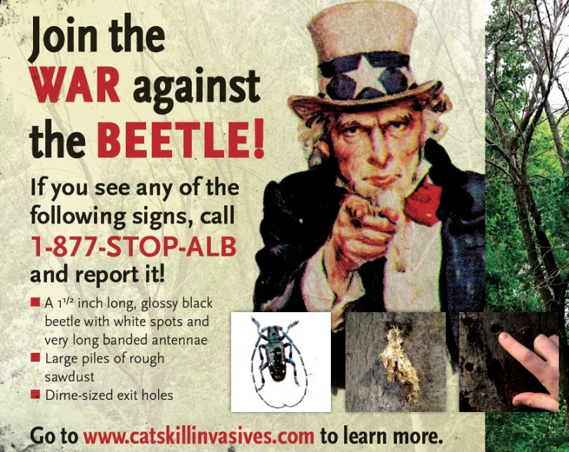
Schoharie Creek Planting
After last year’s flooding, numerous acres of denuded land were left vulnerable to invasive plant species. Working with the Department of Transportation (DOT), a location in Fultonham was identified for a tree-planting effort following work to rebuild Route 30. Officials from the state Department of Environmental Conservation Mohawk River Basin program’s Trees for Tribs Program and Hudson River Trees for Tribs Program provided the trees while CRISP organized approximately 40 volunteers to plant over a thousand trees. Educational signage detailing the project will be erected in 2013.
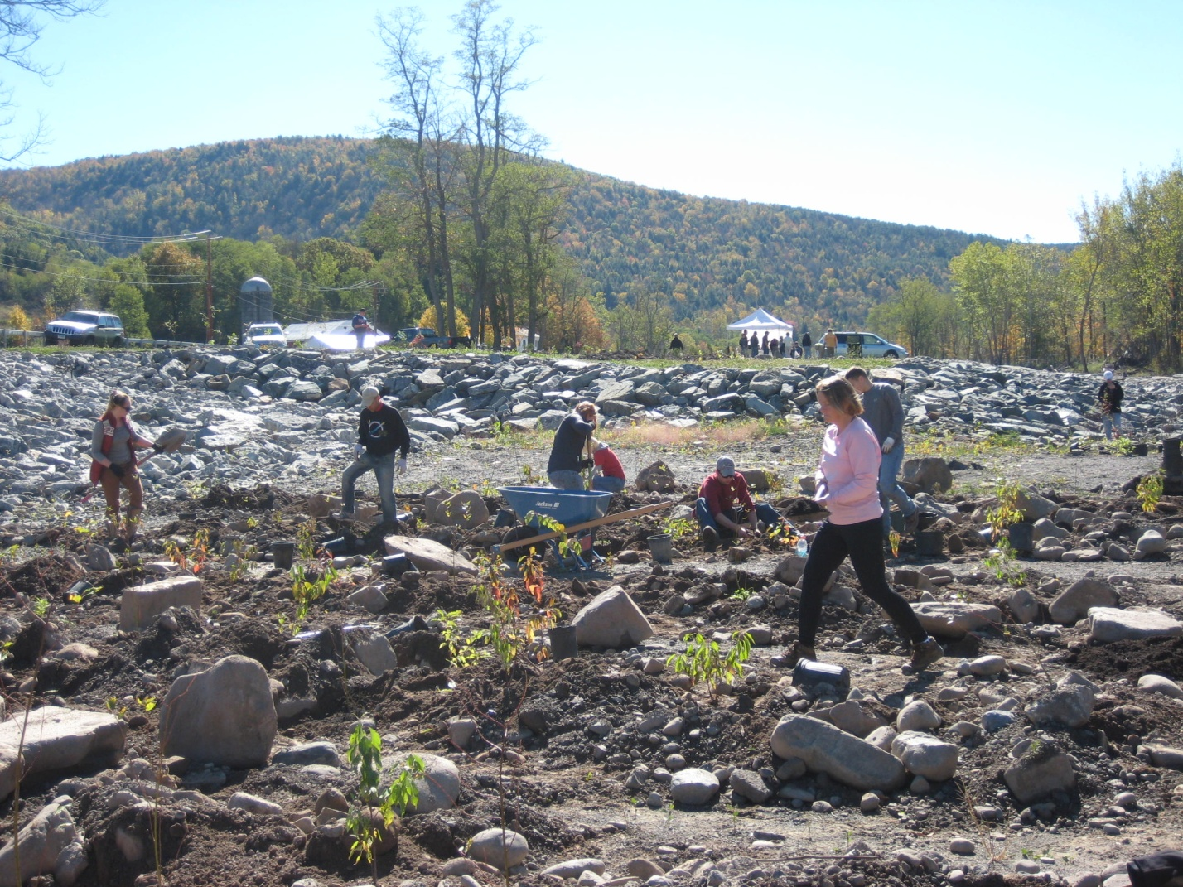
Early Detection / Rapid Response
Boat Stewards
In May, 2012, CRISP and the Biological Field Station at SUNY Oneonta launched a pilot Watershed Steward Program (WSP) to prevent introduction and spread of aquatic invasive species in the CRISP region. Watershed stewards trained by the Biological Field Station staff greeted boaters and anglers, discussed invasive species spread prevention, and collected watershed use data throughout the summer at six high-use water body access sites. Successful outcomes from the program include a Catskill Region Watershed Steward Training manual, suitable for use in future programs, and a data collection sheet to be used by all participating watershed steward programs.
Education and Outreach
CRISP launched this project in 2011 and continued it for a second year, assisting twelve un-infested communities in taking stock of their ash in order to prepare for the emerald ash borer. Whitney Hill, Catskill Invasive Species Assistant and SCA Hudson Valley AmeriCorps member, coordinated this program, training community volunteers to inventory ash trees in public parks and in the public right of way along streets within cities, villages and in hamlet centers. Following the inventory process in each community, CRISP compiled a report detailing the results of the inventory, including tree locations, condition and distance to the street. In addition, reports contained management options for publicly held ash trees. Results and reports were presented to municipal boards of each community in the hopes of encouraging preparations for the emerald ash borer.
Training sessions were held prior to each community inventory. Material covered in training sessions included emerald ash borer biology, EAB management options, ash tree identification, and EAB signs and symptoms. The day of the inventory, volunteers inventoried selected sections of public parks and streets while CRISP stayed at a central location coordinating volunteer activities and conducting outreach to passersby. All municipalities that received CRISP Community Ash Inventory reports demonstrated a level of interest in developing plans to prepare for the emerald ash borer.
Community | Number of Ash | Number of Volunteers
Sidney | 33 | 17
Delhi | 7 | 5
Walton | 21 | 4
Port Jervis | 10 | 9
Oneonta | 18 | 5
Cooperstown | 15 | 2
Schoharie | 10 | 1
Cobleskill | 16 | 6
Liberty | 48 | 3
Livingston Manor | 28 | 3
Wurtsboro | 53 | 16
Monticello | 107 | 7
TOTAL | 366 | 78

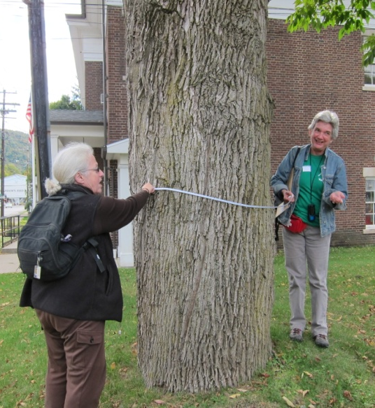

Top Ten Priority Species YouTube Videos
CRISP summer interns, Carrie Carson and Kersten Laveroni, created short videos detailing information on identification and control of CRISP’s priority invasive species. For each video the interns traveled to an infested site to record real footage of the plant. Videos were posted to Facebook, Twitter, and YouTube.
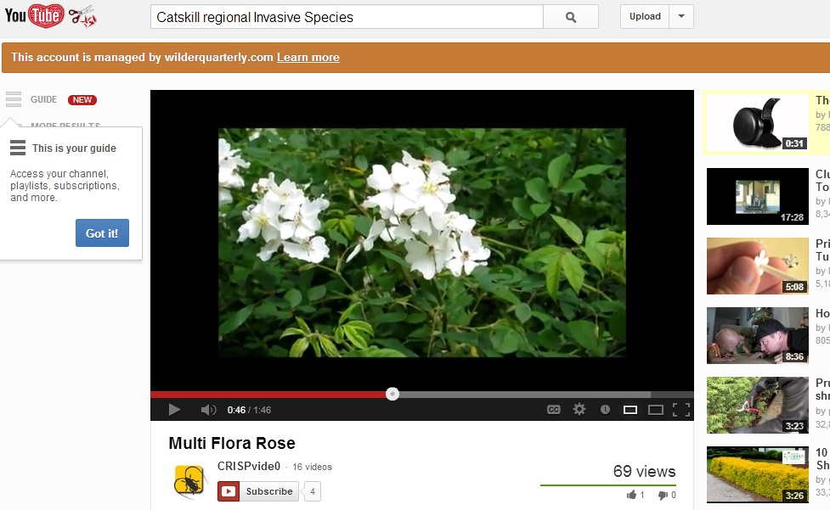

New York City Reservoir Recreational Boating Program Outreach
The New York City Department of Environmental Protection (DEP) opened three new reservoirs for recreational boating in 2012 after the success of the Cannonsville Reservoir Pilot Recreational Boating Program. In partnership with DEP, CRISP worked to increase awareness of the importance of spread prevention given this new potential vector for invasive species introduction. CRISP staff presented information on aquatic invasive species at the kick-off meeting of the steam cleaning vendors in Downsville prior to the start of the boating season.
Once the season was underway a letter describing the threat aquatic invasive species pose to Catskill water bodies as well as CRISP brochures, informational identification cards and Clean Boats, Clean Waters rack cards were mailed to these vendors as well as bait and tackle shops. They were asked to display them prominently to encourage customer awareness of aquatic invasive species issues.
CRISP summer interns also developed an informational YouTube video to accompany a press release that raised awareness of this new recreational opportunity and the importance of preventing new introductions.

Asian Longhorned Beetle (ALB) Mailing
Administrators at schools throughout the Catskill region were sent educational materials to encourage ALB awareness amongst students. Materials mailed included stickers, identification cards, postcards, and large posters. Letters summarizing ALB damage, and encouraging vigilance and reporting were also mailed.
CRISP Brochure
Vibrant Creative, Inc. was contracted to develop a brochure containing information on CRISP’s mission, program offerings, and priority invasive species in the region. Brochures were distributed throughout the region at festivals, community presentations, and other outreach events.
Community Preparedness for Emerald Ash Borer (EAB)
The Emerald Ash Borer Community Support Project, begun in 2011, continued into 2012 with Audrey Kropp, Community Support Specialist. A formalized EAB preparedness plan was written for the previously inventoried town of Woodstock as well as for Greene County. Woodstock has since officially adopted a resolution to mitigate the threats to the town from EAB.
CRISP also continued to support the Ulster and Greene County EAB Task Forces and contracted with Ulster County Department of the Environment to take over the coordination of the Ulster County Task Force. Responsible for facilitating four meetings a year, the Task Force brings state, county, and municipal officials together with concerned citizens and professionals to discuss efforts that can be made to minimize the responsibility of individual communities dealing with EAB and sponsors educational initiatives.

Development of Education and Outreach Materials
CRISP maintains a resource library of materials for distribution by partners. Additional materials developed/printed in 2012 include:
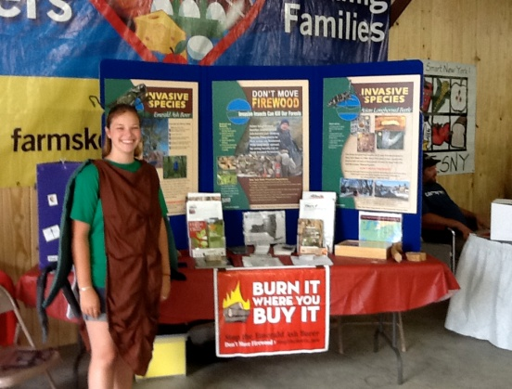
- New CRISP display panel for use at festivals with 5 copied distributed to partners.
- CRISP Top Ten Priority Plants, boat cleaning, hydrilla, feral swine, and EAB Task Forces
- 5,000 CRISP tri-folds containing the Top Ten Priority Plants and EAB/ALB
- 500 CRISP notepads for distribution at festivals
- 300 CRISP pens for distribution at festivals
- Emerald ash borer and Asian longhorned beetle costumes for use at festivals

Information Table for Festival/Event
CRISP staff and interns attended a number of festivals and events in 2012 to promote awareness of invasive species issues and spoke to over 1100 people.
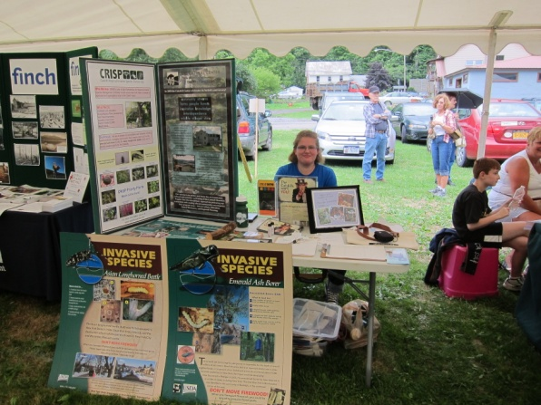
- 35 people 5/19 Kenco Trails Fest, Kingston, NY
- 200 people 7/12-7/28 Orange County Fair, Middletown, NY
- 50 people 7/14 Otsego Lake Day, Cooperstown, NY
- 25 people 7/21 Mine Kill Summer Fest, Gilboa, NY
- 200 people 7/21-8/5 Ulster County Fair, New Paltz, NY
- 50 people 7/28 The Catskill Forest Festival in Margaretville, NY
- 100 people 8/4 Schoharie County Sunshine Fair, Schoharie, NY
- 35 people 8/11 Blueberry Festival, Ellenville, NY
- 200 people 8/15 Delaware County Fair in Walton, NY
- 100 people 8/25 Shandaken Day in Pine Hill, NY
- 50 people 9/22 Wildlife Festival, Blenheim, NY
- 100 people 9/23 Bethel Woods Earth Day Harvest Festival, Bethel, NY

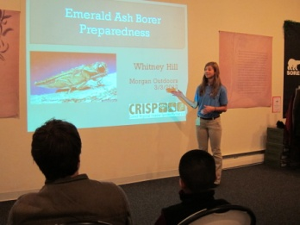
Workshops
      - CRISP held an emerald ash borer preparedness workshop for 15 participants at Morgan Outdoors, Livingston Manor on March 3rd
      - CRISP participated in a workshop on forest pests hosted by The Nature Conservancy in Rutland, Vermont on May 22nd
      - CRISP participated in CCE’s Forestry Friday on August 31st for six participants
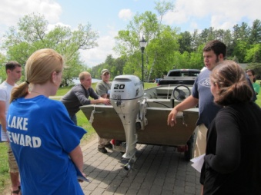
Training Sessions
      - CRISP participated in an invasive versus native plant ID training at the Aton Forest in CT on March 22nd
      - CRISP Participated in a Giant Hogweed control training offered by NYSDEC on May 9th
      - CRISP hosted an iMap Invasives training for participants on May 24th
      - CRISP participated in an iMap Invasives for smartphone training on 5/8/2012
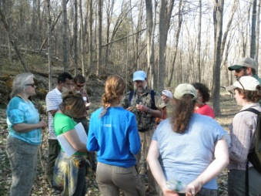
      - CRISP participated in boat steward training on invasive plant identification and proper boat checking/cleaning protocols in Cooperstown, NY on 6/9, Lakawaxen, PA on June 21st and the Paul Smiths College Watershed Stewardship training May 22 – 24th
      - CRISP trained ~6 members of the Catskill Naturalist Program to identify forest pests and recognize their signs and symptoms on June 21st
      - CRISP provided a training on native and invasive aquatic plant identification for ~10 members of the Catskill Naturalist Program on August 14th

Presentations
- 2/21 New York Association of Towns meeting – presented on the emerald ash borer, community ash inventories, and importance of community preparedness for ~6 attendees of the Association of Towns’ Annual Meeting
- 3/13 Town of Shawangunk meeting– presented on forest pests and CRISP
- 5/1 Croton CAC meeting – presented on CRISP and Top Ten Priority Invasives for landowners
- 5/3 Steam Cleaning Vendor Meeting – presented on the threats of aquatic invasive species for the vendors participating in the expanded DEP recreational boating program.
- 5/24 Andes Central School- presented on ash identification and risks of emerald ash borer and Asian longhorned beetle and took ~60 students to tag ash trees
- 5/23 Gilbertsville Central School- presented on ash identification and risks of emerald ash borer and Asian longhorned beetle and took ~6 students to tag ash trees
- 6/2 Max V. Shaul- Discussed the risks of moving firewood to ~3 campers
- 6/6 Bennett Elementary School Earth Day- held session explaining the threat of the emerald ash borer and involved ~100 students in various games to demonstrate risks of moving firewood
- 6/9 Glasco Boy Scouts- presented information regarding identification and control of EAB and ALB to ~70 boy scouts and family members
- 7/17- 7/19- Beetle Busters at Mine Kill State Park- encouraged ~250 children ages 4-13 to learn about forest pests through playing various games and creating various crafts
- 7/22 – Kerhonkson Boy Scouts – conducted an ash tree ID walk and ash tagging along trails at Vernoy Kill Falls for ~ 20 boy scouts and family members
- 7/5, 7/24, 8/15 FrostValley YMCA Day Camp- taught ~65 campers aged 4-7 lessons on emerald ash borer and Asian longhorned beetle and then created invasive species crafts and played forest pest related games

Other
- CRISP attended a Feral Swine information session held by USDA, APHIS, Wildlife services on March 21st
- CRISP attended the Northeast Natural History Conference on April 17th through 19th.
- CRISP, in cooperation with CCE Greene County tagged over 100 ash trees at Mountain Top Arboretum in Tannersville on October 13th

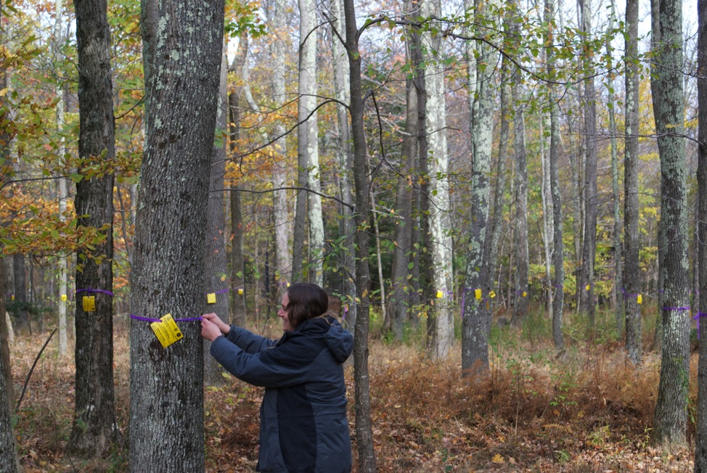
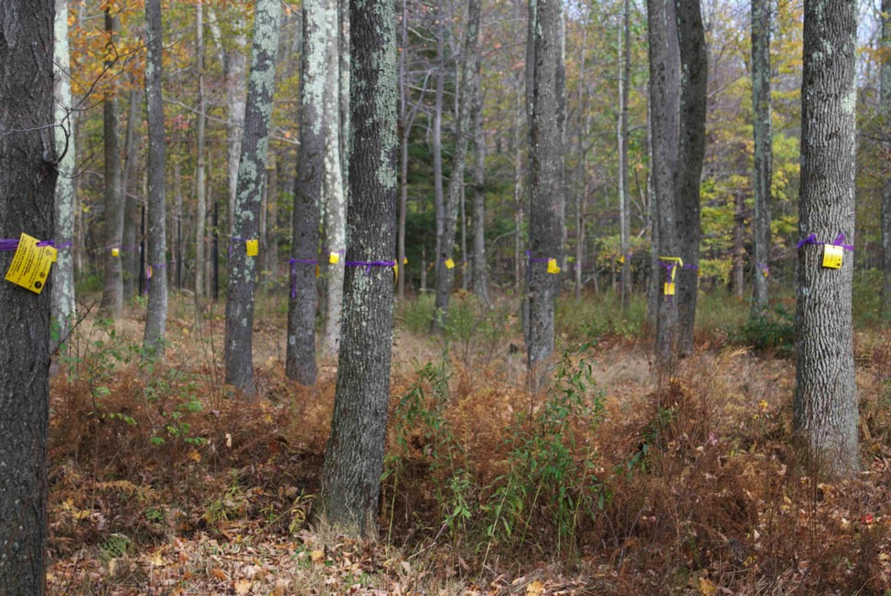
Control
Giant Hogweed
Throughout the summer CRISP continued to control infestations of giant hogweed within Otsego, Ulster and Sullivan Counties. Populations were controlled using root cutting, with the exception of a single site in Sullivan County which was controlled using flower head removal. Five additional sites were monitored during the summer to ensure previous control efforts had been effective. The ‘Giant Hogweed Management Plan for Catskill Regional Invasive Species Partnership’ was completed in October of this year and will help to coordinate efforts for all partners working to control this noxious species. CRISP plans to have all current hogweed infestations within the region eliminated by 2018.
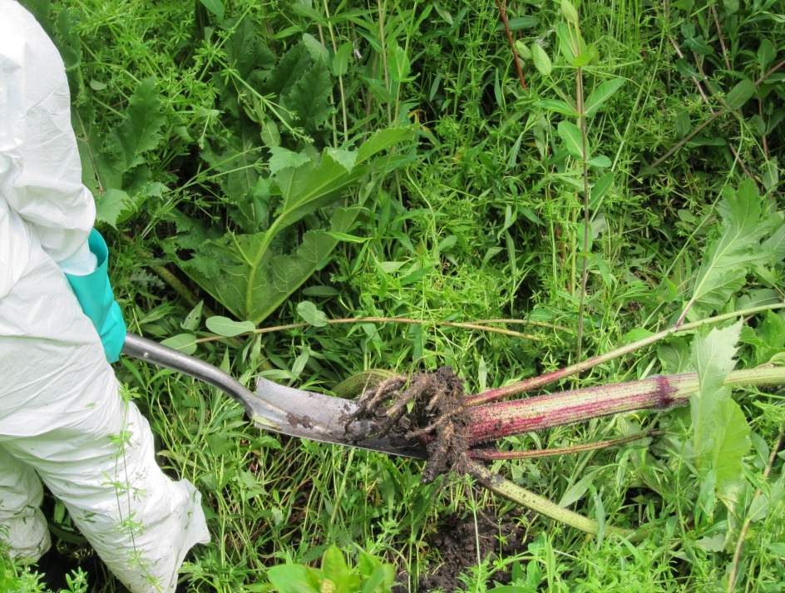

Water Chestnut
In 2012 CRISP assisted with hand pulling efforts in Swan Lake in Sullivan County, removing over 200 water chestnut plants. CRISP met with landowners to discuss the possibility of chemical treatment to help advance water chestnut control in the County.

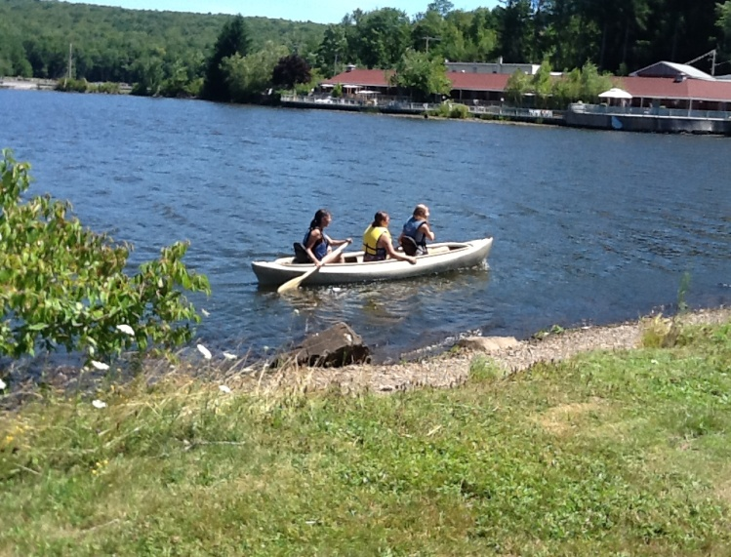
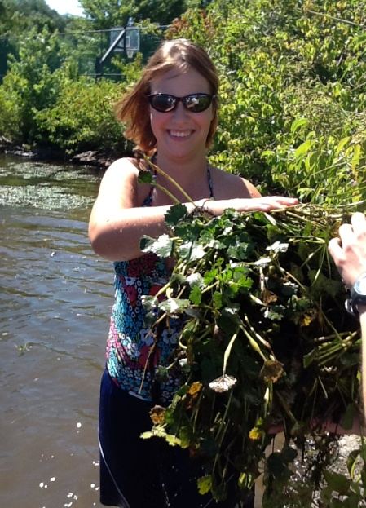

Organizational

Ongoing Planning
- The CRISP Strategic Plan for the next 5 years finalized
- Forest Management Plan
- Work towards signatures on the CRISP Cooperative Agreement by spring 2013
- CRISP contracted with the SCA program to host two more 10-month SCA Hudson Valley AmeriCorps interns in 2013. One intern will focus on biological control research and implementation and the other on social media and outreach.

