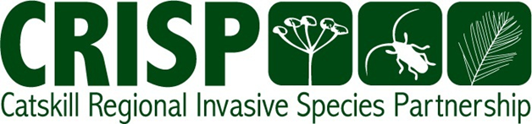

Prepared By:

John Thompson  
Catskill Regional Invasive Species Partnership Coordinator

Dan Snider-Nerp

Field Projects Manager

Catskill Regional Invasive Species Partnership

Catskill Center for Conservation and Development

Arkville, New York

**CRISP Team performing Giant Hogweed Treatment, Delaware County 7/12/21**

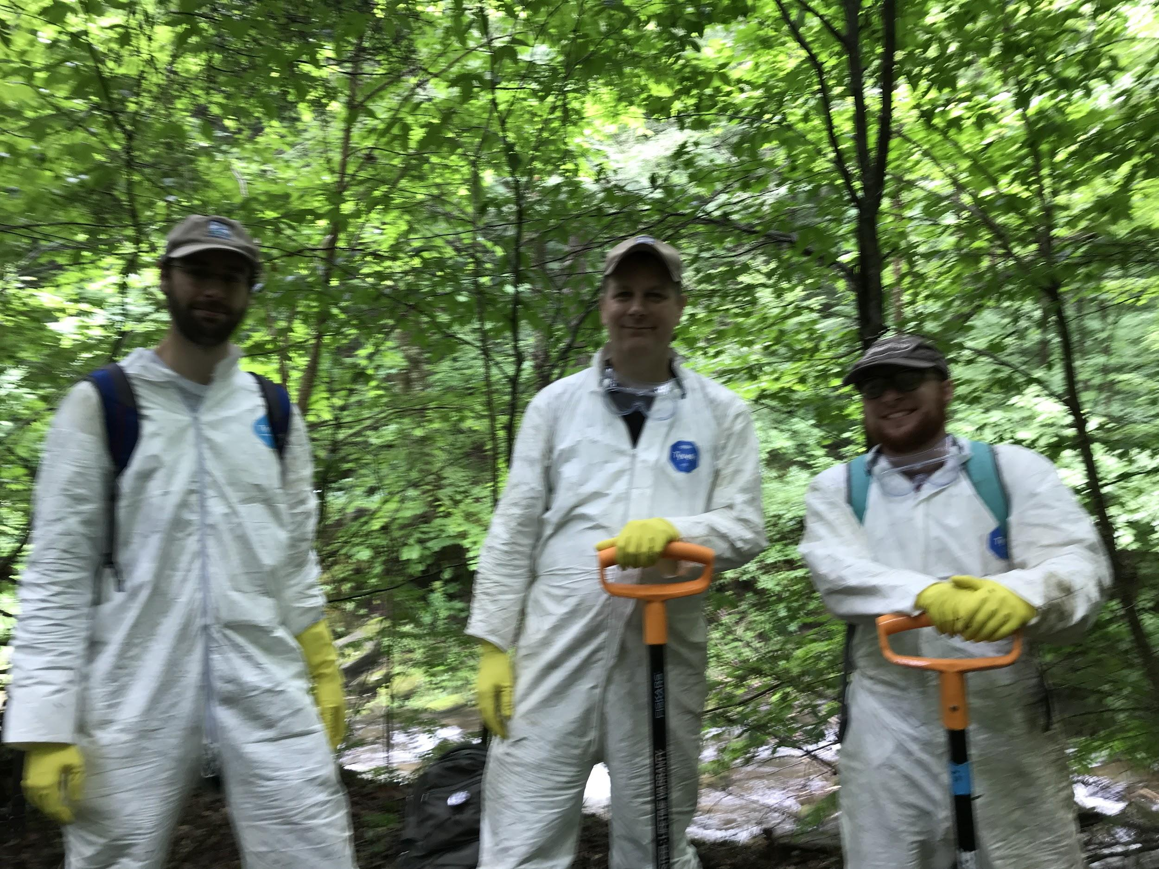

2021 Annual Report



# 

**Figure 1. Mile-a-minute infestation, Davenport.**

# Executive Summary

During 2021 the Catskill Regional Invasive Species Partnership (CRISP) continued to perform Rapid Response, organized control efforts, led trainings, and gave prevention and awareness presentations during the second year of the COVID-19 pandemic. CRISP documented and treated four new infestations of high-priority Early Detection species. CRISP provided 21 total invasive species trainings and education programs for 987 participants.

CRISP managed 104 invasive species infestations in 2021, working with the Catskills Strike Team. The sustained rapid response of the CRISP team resulted in two giant hogweed populations being eradicated. Removals of Tier 2 species were performed over 2.5 acres: mile-a-minute, black jetbead, Japanese angelica tree, and Japanese hop.

CRISP began strategic planning for invasive species management jointly with the New York City Department of Environmental Protection. The first activity of brainstorming generated 161 ideas by stakeholders These ideas were submitted through 84 contributions. Additional input will be solicited from stakeholders in 2022 and a report will be completed by March 2022.

Projects funded by CRISP in 2021 included:

* Canadarago Lake Improvement Association, “Aquatic Invasive Species Prevention Program”
* Cornell Cooperative Extension Columbia-Greene, “CRISP Education and Outreach”
* Matty’s Landscaping, for maintenance of Hemlock Insectary and Native Planting at Thorn Preserve
* Otsego County Conservation Association, “Greater Otsego County Aquatic Invasive Species and Japanese Angelica Tree Response”
* SUNY Oneonta, “CRISP Watershed Stewards Program”

During the 2021 season, the CRISP Watershed Stewards Program submitted 6,064 surveys. Canadarago Lake completed one-third of the surveys and was the top contributor of data. A total of 570 potentially invasive plants and animals were intercepted by CRISP Watershed Stewards.

CRISP was involved in three Catskill Science Collaborative Fellowship projects:

* Marissa Kordal (SUNY Cortland) “Understanding the single and combined effects of co-occurring stressors: white-tailed deer, invasive earthworms and invasive plants.”
* Thomas McKiernan and Hanny Mendoza (Binghamton University) “Modeling the Susceptibility of Catskill Waterbodies to Invasive Plants and Animals.”
* Kelsey Parker (CUNY) “Developing novel techniques of remote sensing to monitor hemlocks in the Catskills.”

# Acknowledgments

The bulk of the Catskill Regional Invasive Species Partnership funding was provided from the Environmental Protection Fund as administered by the New York State Department of Environmental Conservation. Additional funding was provided by the New York City Department of Environmental Protection for strategic planning for invasive species management.

# Contents

Executive Summary 1

Acknowledgements 2

Contents 3

Introduction 4

Strategic Planning 5

Prevention 7

Early Detection and Rapid Response 11

Control and Restoration 15

Awareness 16

Science 19

Partnership 20

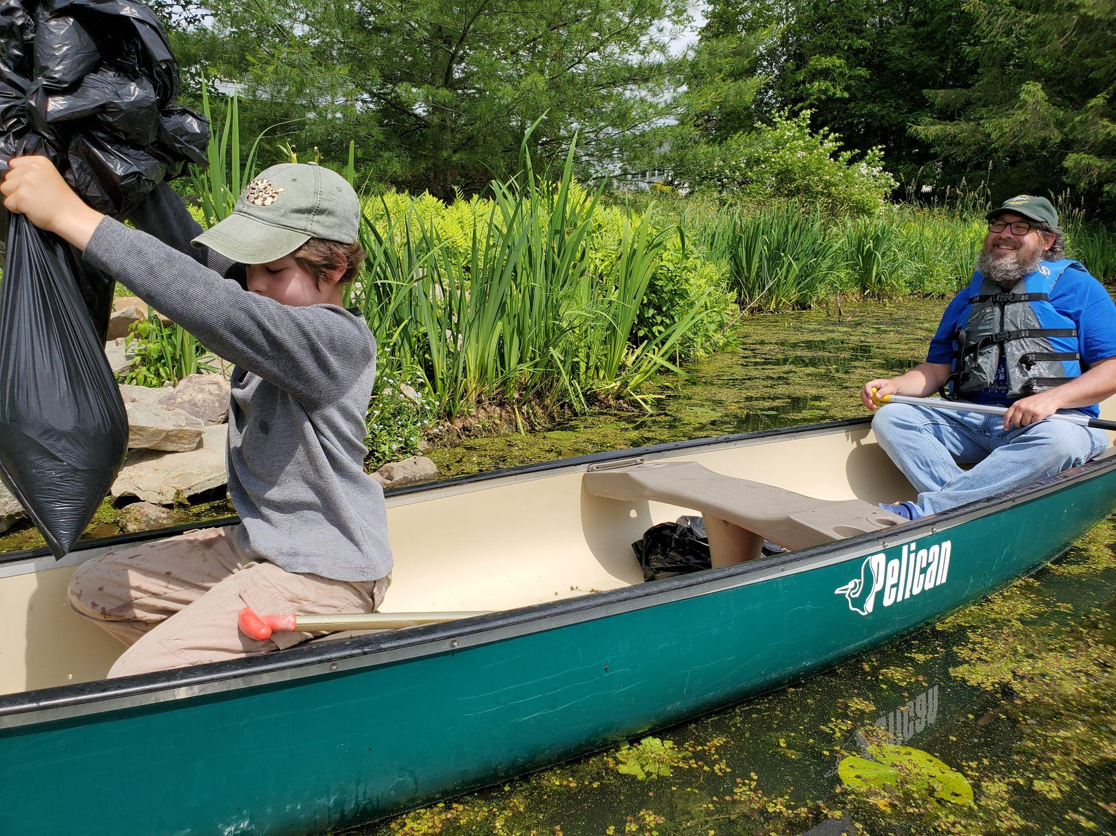

**Figure 2. AIS Pull, Otsego County Conservation Association.**

# Introduction

# Hosted by the Catskill Center, the Catskill Regional Invasive Species Partnership (CRISP) has coordinated and collaborated with state, regional, and local governmental, for-profit, and nonprofit entities including other Partnerships for Regional Invasive Species Management (PRISM) across the state, the DEC Invasive Species Coordination Section, the New York Invasive Species Research Institute, and the New York State Hemlock Initiative among many others. In recent years, CRISP has worked with the surrounding PRISMs to address cross-boundary issues such as: spotted lanternfly early detection with the Lower Hudson PRISM; addressing a common frogbit source population in the Capital Region PRISM; and co-chairing, with the Finger Lakes PRISM Coordinator, the Invasive Species Working Group for the Upper Susquehanna Conservation Alliance. CRISP coordinates with other PRISMs through the PRISM Education and Outreach Group and the Terrestrial Coordinators Group. CRISP has worked with the New York Invasive Species Research Institute to identify statewide research priorities, develop statewide invasive species management metrics, and identify scientists in fields relevant to CRISP, such as those studying the impact of hemlock decline on water quantity and quality. CRISP works with the New York State Hemlock Initiative on joint trainings, educational programs, and identifying Catskill sites for biocontrol release. CRISP also coordinates with the DEC Invasive Species Coordination Section on education and outreach initiatives, including NY Invasive Species Awareness Week, early detection and management of Japanese tree lilac, aquatic invasive species management, and modeling aquatic invasive species.

**Figure 3. CRISP Watershed Steward at Portlandville**

The Catskill Center proposes to expand CRISP’s capacity to perform education, early detection and rapid response, and build its relationships with research institutions through the addition of several staff positions, as previously described. By increasing communications and technical capacity, CRISP will be able to collaborate more frequently and effectively with other PRISMs and NYS invasive species programs on shared projects to promote both regional and statewide initiatives. Increased coordination will help CRISP achieve more invasive species control on the ground and in the water.

The CRISP region is important for the biodiversity it supports and the work of CRISP and its partners help to protect that ecology. The CRISP region supports 78 state rare plants and animals and 22 state rare communities.

.

# Strategic Planning

The year 2021 marked the last year of the CRISP 2017-2021 five-year contract. Considering the possibility of being able to adapt the program to better meet both current and future needs, the CRISP Steering Committee discussed potential improvements to increase effectiveness of the CRISP program. The Steering Committee considered the areas that CRISP was being most effective in and the areas in which CRISP could improve. Also, the committee considered the upcoming challenges in the CRISP region with the spread of species such as spotted lanternfly, northern snakehead, and quagga mussels. Ideas that were strongly recommended by the Committee included adding an aquatic invasive species position and positions to expand education and outreach and volunteer coordination. Considering the challenges in getting licensed applicators to perform rapid response in CRISP, the need to have both a CRISP terrestrial and an aquatic strike team were identified as priorities. The CRISP Coordinator met with other PRISM Coordinators to discuss staffing and programs in their regions, and the Steering Committee recommendations were in line with the size and structure of other PRISM programs.

The Catskill Partnership for Regional Invasive Species Management Contract Request for Proposals was issued by New York State Department of Environmental Conservation on June 15th and due on July 30th. The Catskill Center submitted a proposal to continue to administer CRISP from 2022 to 2026. The CRISP Proposal included staffing suggestions made by the Steering Committee. The Catskill Center’s proposal was selected and negotiations on budget ensued. Changes to CRISP in the new contract will include transitioning the Field Project Manager position to Terrestrial Manger, adding an Aquatics Manager, adding a Volunteer and Outreach Coordinator, and adding both a two-person Terrestrial Strike Team and a two-person Aquatics Strike Team.

CRISP staff and the CRISP Steering Committee worked with New York City Department of Environmental Protection (NYC DEP) to begin a process of doing collaborative planning for invasive species management. Meredith Taylor, CRISP Steering Committee Chair, and John Thompson worked with Bryan Dailey, of Cornell University, to perform a stakeholder input process called Group Concept Mapping (GCM). Group Concept Mapping was the method used by the New York Invasive Species Research Institute to summarize input from multiple stakeholders to identify research priorities for New York State invasive species management. This methodology was selected to gather priority ideas for management from CRISP stakeholders and NYC DEP employees involved in invasive species management.

The goals of the joint CRISP/NYC DEP strategic planning for invasive species management were to gain input from a large number of stakeholders to perform the following:

1. Identify invasive species management priorities in the CRISP region,
2. Rank the invasive species management priorities by importance,
3. Rank the invasive species management priorities by feasibility, and
4. Determine the organization that should be responsible for each priority.

The GCM project was initiated in 2021 and completed in 2022. To begin the project, an email list of 143 email addresses was assembled from CRISP and NYC DEP stakeholders. Links were sent to these email addresses and the CRISP listserv (which totaled 287 email addresses) to notify stakeholders that input was being sought to contribute to invasive species management planning in the CRISP region. In addition, the same information and a link to contribute were posted on the CRISP website. The initial email included the following text:

Catskill Regional Invasive Species Partnership (CRISP) is working with partners to address invasive species issues in the greater Catskills region (<https://www.catskillinvasives.com/updates>). New York City Department of Environmental Protection (NYC DEP) has an invasive species program to protect the upstate water supply from invasive species threats to water quality and infrastructure. CRISP and NYC DEP are working together on a group concept mapping project to guide strategic planning specifically for invasive species management for the next 5 years. To assist us in this effort, we are looking for input from a variety of stakeholders with expertise in a broad range of geographic and taxonomic areas. When responding, please keep in mind that we are expecting ideas related to invasive species applied management goals (as opposed to general education or research goals).

You will find a link below to start the process. The first phase is brainstorming, where we invite you to contribute your ideas.

The brainstorming phase of this Group Concept Mapping Project was a request for each stakeholder to complete the prompt: “One specific invasive species priority in the CRISP Region in the next five years is…”

The first activity of brainstorming generated 161 ideas by stakeholders. These ideas were submitted through 84 contributions. Because the activity was done anonymously, we do not know the exact number of participants and some stakeholders may have contributed more than once. Common themes submitted included early detection, rapid response, education, and outreach. There were also several specific species that were submitted multiple times, including beech leaf disease, jumping worm, spotted lanternfly, and hemlock woolly adelgid.

Subsequent GCM activities will be completed in 2022 and a report will be completed by Bryan Dailey in 2022.

# Prevention

A major emphasis of CRISP efforts and resources focused on preventing the introduction of invasive species into the CRISP region. CRISP again subcontracted with SUNY Oneonta to provide a Watershed Stewards Program (WSP) for the ninth consecutive year. In addition, CRISP subcontracted with the Canadarago Lake Improvement Association, to support the Canadarago Lake Watershed Steward Program. During the 2021 season, 6,064 surveys were submitted by the CRISP WSP, a decrease from 2020. Canadarago Lake completed one-third of the surveys and was the top contributor of data. Otsego Lake’s Lakefront launch submitted 1,300 surveys in 2021, almost 700 less than in 2020. Most sites were staffed by one steward consistently throughout the summer (Table 1) while others were on a rotation or only worked for special events.

Table 1. CRISP AIS sites staffed in 2021 with typical steward staffing and total days staffed.

|  |  |  |
| --- | --- | --- |
| **Sites** | **Number of Stewards** | **Days Staffed** |
| **NYSDEC Signed Sites** |  |  |
| Barking Dog, Delaware River | 1 | 48 |
| Gentleman’s Club, Delaware River | 1 | 47 |
| Vlaie Pond, Town of Broome | 0.5 | 29 |
| Looking Glass Pond, Town of Summit | 0.5 | 17 |
| Otego, Susquehanna River | 0.5 | 14 |
| Unadilla, Susquehanna River | 0.5 | 17 |
| Greens Lake, Town of Athens | 0.5 | 36 |
| North-South Lake, Hamlet of Palenville | 0.5 | 53 |
| Crumhorn, Susquehanna River | 1 | 75 |
| Emmons, Susquehanna River | 0.5 | 24 |
| Sidney, Susquehanna River | 0.5 | 40 |
| Narrowsburg, Delaware River | 1 | 78 |
| Colliersville, Susquehanna River | 0.5 | 12 |
| Portlandville, Susquehanna River | 1 | 74 |
| East Sidney Lake, Susquehanna River | 1 | 10 |
|  |  |  |
| **Non-NYSDEC Sites** |  |  |
| Canadarago Lake | 1 | 83 |
| Otsego Lake, Fish Road | 2 | 98 |
| Otsego Lake, Lake Street | 2 | 98 |
| Brookwood Point, Otsego Lake | 0.5 | 17 |

Training was provided with a combination of online and in-person training (following safety protocols and a limited number of people). In-person training was offered to groups of four individuals at a time. This training model was effective and may be continued into 2022. The first WSP training session was held in April. The training session consisted of 15 NYS DEC and Canadarago Lake Stewards. A second online training session was conducted in May with 20 stewards participating. Training evaluation forms were completed for thirty Watershed Stewards.

Each steward was provided flashlights and mirrors and were given the updated CRISP field manual (in book form) for the WSP and as flash drives (for the stewards). CRISP WSP T-shirts were provided along with packets containing relevant information and rack cards. Stewards were also provided tables, chairs, and umbrellas to display rack cards and specimen samples. Spray bottles were handed out to all stewards, along with rakes and pool skimmers for clearing the boat launch. Stewards were provided PPE and 10% bleach solution to follow safety guidelines and sanitize their stations. Tablets were provided to all stewards. All tablets were returned at the end of the season.

A total of 20 sites, including 15 DEC accesses, had Steward coverage in 2021. Coverage of launches in Schoharie and Greene Counties was increased in 2021, but coverage of Sullivan County decreased. A rotating schedule of stewards was implemented to travel to Sullivan County once every two weeks.

The Village of Cooperstown was able to fund and hire one full-time steward for the Lake Front public launch. Between the Village steward and our NYS DEC stewards, Lake Front and the adjoining Fish Road launch were well covered this season.

Quagga mussels (*Dreissena bugensis*) are a continuing issue in Otsego Lake. Though no quagga mussels were found on any watercraft or equipment, they have spread rapidly in Otsego Lake. SCUBA surveys have shown that they are numerous and outcompeting their congeners, the zebra mussel (*Dreissena polymorpha*). A study is ongoing by Professor Kiyoko Yokota, of SUNY Oneonta, to determine their impact. Stewards trained for 2022 will be made aware of this new threat and encouraged to power wash and tag all boats leaving Otsego Lake. No quagga mussels have been found in nearby Canadarago Lake, but the lake will continue to be surveyed.

Over half of the watercraft seen in the CRISP PRISM were kayaks or motorboats. Of the 7,688 watercraft surveyed, 3,428 were non-motorized. Kayaks and canoes make up most of the traffic on monitored CRISP Region rivers and some lakes (Table 2). Boaters overwhelmingly reported fishing and general recreation as their primary activity (Figure 1).

Table 2. CRISP region watercraft type by site in the 2021 season.

|  |  |  |  |  |  |  |  |  |  |
| --- | --- | --- | --- | --- | --- | --- | --- | --- | --- |
| Site | Barge | Canoe | Kayak | Motorboat | PWC | Rowboat | Sailboat | SUP | Windsurfer |
| Barking Dog | 0 | 2 | 13 | 3 | 0 | 88 | 0 | 0 | 0 | |
| Gentleman’s Club | 0 | 1 | 10 | 0 | 0 | 0 | 0 | 0 | 0 | |
| Vlaie Pond | 0 | 9 | 62 | 1 | 0 | 5 | 0 | 2 | 0 | |
| Looking Glass Pond | 0 | 0 | 3 | 0 | 0 | 0 | 0 | 0 | 0 | |
| Otego | 0 | 6 | 49 | 0 | 0 | 0 | 0 | 0 | 0 | |
| Unadilla | 0 | 2 | 107 | 0 | 0 | 0 | 6 | 0 | 0 | |
| Greens Lake | 0 | 13 | 180 | 28 | 2 | 8 | 0 | 34 | 1 | |
| North-South Lake | 0 | 19 | 143 | 0 | 0 | 5 | 1 | 16 | 0 | |
| Crumhorn | 0 | 55 | 260 | 144 | 10 | 1 | 0 | 3 | 0 | |
| Emmons | 0 | 6 | 15 | 0 | 0 | 0 | 0 | 1 | 0 | |
| Lake Front | 2 | 42 | 346 | 972 | 88 | 1 | 20 | 65 | 0 | |
| Sidney | 0 | 7 | 27 | 0 | 0 | 0 | 0 | 3 | 0 | |
| Narrowsburg | 0 | 96 | 629 | 74 | 0 | 22 | 0 | 44 | 0 | |
| Canadarago Lake | 6 | 21 | 252 | 2273 | 144 | 3 | 5 | 26 | 2 | |
| Springfield | 0 | 3 | 43 | 165 | 12 | 8 | 1 | 8 | 0 | |
| Colliersville | 0 | 4 | 5 | 0 | 0 | 0 | 0 | 0 | 0 | |
| Brookwood Point | 0 | 4 | 20 | 0 | 0 | 0 | 0 | 2 | 0 | |
| Portlandville | 0 | 87 | 551 | 6 | 0 | 3 | 0 | 16 | 0 | |
| East Sidney Lake | 0 | 2 | 44 | 247 | 69 | 2 | 0 | 1 | 0 | |

Figure 4. Primary activity boaters reported in the 2021 season when questioned by CRISP AIS and WSP stewards.

Most boaters surveyed were familiar with boat stewards (90%) and took spread prevention measures prior to launching (71%). Familiarity with boat stewards increased from last year’s 81%, however, boaters took fewer prevention measures prior to launching in 2021. Most boaters either dried their boat, drained standing water, or inspected the craft prior to launching. About half of boaters were returning visitors at their waterbodies or had not launched in the past two weeks. The CRISP Region had a 98% compliance rate, slightly higher than last year. Avoidance due to COVID made up about 40% of the reasons watercraft were not inspected in 2021.

During the 2021 season, 518 angler surveys were submitted. The compliance rate was slightly lower (95%), but the overwhelming majority either fished in the same waterbody or their equipment hadn’t been used in the past two weeks. Few organisms were found on fishing equipment and what was found was mostly debris or mud.

Overall, 570 potentially invasive plants and animals were found and prevented from leaving or entering CRISP water bodies (Table 3). Pondweeds (*Potamogeton* sp.) and milfoils (*Myriophyllum* sp.) were commonly found on boats launching and retrieving, as was mud and debris. Waterweed (*Elodea* sp.) and water celery (*Vallisneria americana*) were often pulled from boats leaving Canadarago and Otsego Lakes. Zebra mussels (*Dreissena polymorpha*) were found and brought to a boat-wash to be killed and removed. No reports of Hydrilla or Spiny water-flea (*Bythotrephes longimanus*) were made. Canadarago, Portlandville, and several other launches encountered water chestnut (*Trapa natans*) several times in the 2021 season. Both Otsego Lake and Canadarago Lake had water chestnut plants growing near launches this summer. All plants were pulled on Otsego Lake, and the area in which they were found will be monitored. The Canadarago Lake Improvement Association (CLIA) is developing a plan to control water chestnut in Canadarago Lake. All other reported invasives were known to the waterbody.

Table 3. Sites staffed by CRISP AIS stewards and percent of boats on which AIS were found during launch or retrieval.

|  |  |  |
| --- | --- | --- |
| **Site** | **% Launching** | **% Retrieving** |
| Barking Dog | 93% | 7% |
| Gentleman’s Club | 100% | 0% |
| Vlaie Pond | 0% | 100% |
| Looking Glass Pond | 100% | 0% |
| Otego | 72% | 28% |
| Unadilla | 82% | 18% |
| Greens Lake | 84% | 16% |
| North-South Lake | 92% | 8% |
| Crumhorn | 62% | 38% |
| Emmons | 50% | 50% |
| Lake Front | 71% | 29% |
| Sidney | 56% | 44% |
| Narrowsburg | 63% | 37% |
| Canadarago Lake | 82% | 18% |
| Springfield | 57% | 43% |
| Colliersville | 0% | 0% |
| Brookwood Point | 73% | 27% |
| Portlandville | 55% | 45% |
| East Sidney Lake | 79% | 21% |

# Early Detection and Rapid Response

CRISP managed 104 sites for invasive species in 2021. Invasive species surveys were conducted over 466 acres. Treatments were performed on 12.4 acres of invasives and 2.5 acres of Tier 2 species. The goal of Early Detection and Rapid Response (EDRR) efforts are to increase the likelihood that invasions will be detected and eradicated before they become established. Rapid response was performed on giant hogweed, mile-a-minute, black jetbead, Japanese angelica tree, and Japanese hop.

Giant hogweed was eradicated at 2 sites in 2021 and six sites remain under management. We visited eight giant hogweed sites in 2021: One site had one plant, and one site had 48% fewer stems than the previous year. We were unable to visit one site because the landowner did not respond to numerous requests and permission to access was therefore not obtained.

At the end of September, mile-a-minute was reported for the first time in Delaware County. The landowner was immediately contacted and permission was acquired to survey the property and do removals. The area was surveyed and found to cover 3.6 acres over several private properties with a disjunct population on municipal lands. CRISP staff and volunteers removed 55 contractor bags of mile-a-minute fruits and vines from the site before the fruits dropped and further spread the plant. Unfortunately, some patches are close to Charlotte Creek and its tributaries. Charlotte Creek may be a vector for spread. More surveys will need to be done in 2022 to determine if there are patches downstream, or upstream.

Northern snakehead, first reported in the Upper Delaware River in 2020, continued to be reported in the Delaware. In addition, northern snakehead was documented in the Bashakill Wildlife Management Area, in Lower Hudson PRISM, but close to the eastern border of CRISP. DEC Fisheries performed surveys and eDNA surveillance to determine the extent of populations.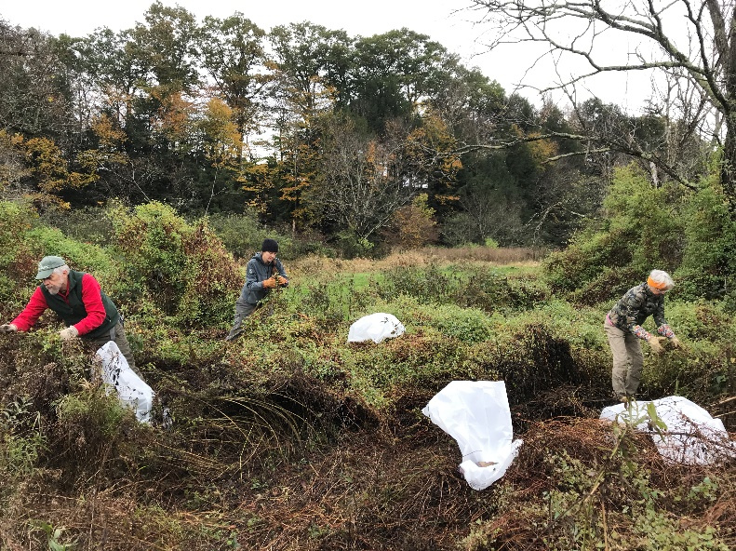

Dan Snider-Nerp, CRISP Field Projects Manager, performed treatment of Japanese angelica tree at one 0.06 acre site on private land in Woodstock.

**Figure 5. Volunteer mile-a-minute pull at Davenport.**

Otsego County Conservation Association again led Common frogbit detection surveys and removals at Youngs Lake, Clarke Pond, and Cripple Creek, with the goal to suppress spread into Otsego Lake.

CRISP staff and the Early Detection Working Group worked with Dylan Finley and the iMapInvasives program to finalize a prioritized invasive species list for 2021, using a data-driven approach. The Invasive Species Tiers were developed between New York State iMapInvasives staff and the Partnership for Regional Invasive Species Management Coordinators. Each very high, or high, impact invasive species was assigned to the following tiers (See Tier 2 invasive species, Table 4):

**• ‘**Tiers 2-4’: species with a ‘high’ or ‘very high’ NYS Ecological Impact rank or a ‘very high negative’ or ‘significant negative’ NYS socio-economic impacts rank. Those with the lowest 33% population counts are designated Tier 2, the middle 33% Tier 3, and the upper 33% Tier 4.

• ‘Tier 1a’ - species within a 100-mile buffer of the PRISM that are not already present within the PRISM.

• ‘Untiered in PRISM’– Contains any species present in the PRISM that has neither a high ecological nor socio-economic impact.

• ‘Untiered in Buffer’ - species within a 100-mile buffer of the PRISM that are not already present within the PRISM.

The Tier 2 Species List shows those species that were targeted for early detection surveys. In some instances, landowner permissions were not obtained, so surveys could not be performed. In other cases, populations were not visited in 2021 due to staff limitations.

Table 4. 2021 Tier 2 Invasive Species.

| **Scientific name** | **Common name** |
| --- | --- |
| *Akebia quinata* | chocolate vine |
| *Najas minor* | brittle water nymph |
| *Nymphoides peltata* | yellow floating-heart |
| *Osmerus mordax* | rainbow smelt |
| *Hydrocharis morsusranae* | common frogbit |
| *Clematis terniflora* | Japanese virgin's-bower |
| *Aldrovanda vesiculosa* | waterwheel plant |
| *Dreissena bugensis* | quagga mussel |
| *Euonymus fortunei* | winter creeper |
| *Heracleum mantegazzianum* | giant hogweed |
| *Humulus japonicus* | Japanese hop |
| *Kolkwitzia amabilis* | beautybush |
| *Lamiastrum galeobdolon* | yellow arch-angel |
| *Lilioceris lilii* | lily leaf beetle, scarlet lily beetle, red lily beetle |
| *Miscanthus sinensis* | Chinese silvergrass |
| *Paulownia tomentosa* | princess-tree |
| *Persicaria perfoliata* | mile-a-minute weed, mile-a-minute vine |
| *Pyrus calleryana* | Callery pear |
| *Rhodotypos scandens* | black jetbead |
| *Syringa reticulata* | Japanese tree lilac |
| *Vincetoxicum rossicum* | European swallow-wort, pale swallow-wort, dog strangling vine |

The Early Detection Working Group will review this list annually, recategorizing species based on updated population information and the best information available.

# Control and Restoration

In recent years, the Catskill Center has greatly increased its capacity to perform rapid response and control. The total area managed in 2021 was 930 acres. A total of 466.3 acres were surveyed and 12.41 acres of invasives were treated.

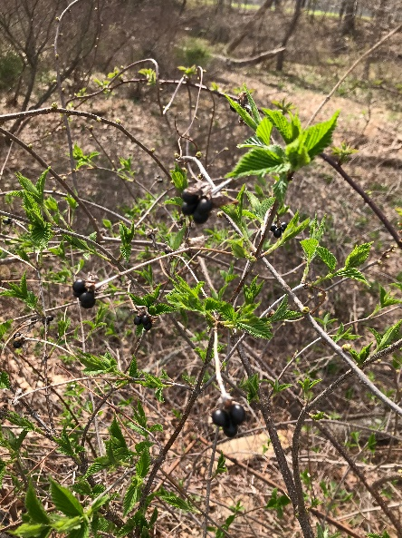This was the third and final year of the Catskill Center’s “2019 Catskill Invasive Plant Rapid Response and Control” DEC grant for the purpose of expanding rapid response and control in the Catskills. The grant supported two Catskills Strike Team Technicians for the last three field seasons to assist the CRISP team on early detection and rapid response to giant hogweed, mile-a-minute, black jetbead, Japanese hops, and Japanese tree lilac. In addition, the Strike Team mapped and removed Asiatic bittersweet, Japanese barberry, and Japanese knotweed (in selected areas where it was deemed feasible). The Catskills 2021 Strike Team, consisting of Skyler Susnick and Andrew Balogh, surveyed 560 acres at 29 sites that included DEC Campgrounds, and other public sites. The Strike Team performed control over 11.1 acres of invasive species. Since 2017, CRISP staff and the Catskills Strike Team have surveyed 4,690 acres.

**Figure 6. Black jetbead fruits.**

CRISP continued maintaining 2 acres of ecological restoration sites in 2021 at the Catskill Center’s Catskills Visitor Center and the Thorn Preserve.

# Awareness

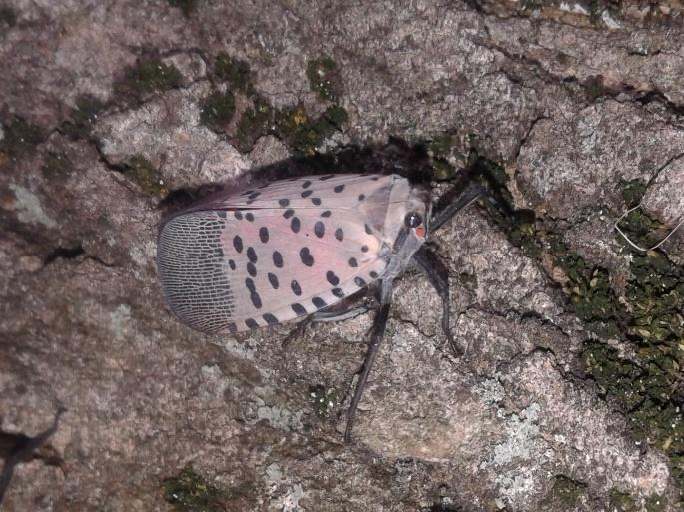In 2021, CRISP led a total of 21 events for 987 participants. Trainings were offered to perform identification, reporting, early detection, control, and prevention of invasive species and community science training. Programming was offered both remotely and in-person. The most popular program was the “Jumping Worms are Invading” webinar, with 400 participants, offered with Catskill Mountainkeeper. Because spotted lanternfly is spreading in our region, identification and reporting of spotted lanternfly were included in most programming.

**Figure 6. Spotted lanternfly.**

**Figure 7. Spotted Lanternfly (photo taken in PA).**

## Table 5. CRISP 2021 Trainings.

|  |  |  |
| --- | --- | --- |
| **Date** | **Title** | **# Participants** |
| 3/20 | Management Techniques for Common Invasive Plants in the Catskills | 16 |
| 3/31 | Managing Common Garden Invasives | 70 |
| 4/8 | Water Connects Us: Invasives | 9 |
| 4/8 | Landscape & Public Space Maintenance Training - Knotweed Mgmt | 4 |
| 6/12 | Trees for Tribs Maintenance | 1 |
| 10/28 | Volunteer Mile-a-minute Training | 3 |
| **Total** (6) |  | **103** |

## Table 6. CRISP 2021 Awareness Programs and Events

| **Date** | **Title** | **# Participants** |
| --- | --- | --- |
| 2/9 | Catskill Regional Invasive Species Partnership | 49 |
| 2/10 | New Enemies and Old Challenges: Approaching Threats and Common Species You Need to Know | 51 |
| 3/20 | View of the Horizon: Invasive Species to Look for this Year | 16 |
| 3/31 | CRISP Partners Meeting, “Managing for a Common Trio: Invasive Earthworms, Invasive Plants and Deer” | 27 |
| 4/17 | What's Bugging Our Forests? Impacts of Invasive Pests on the functioning of Catskill Forests | 16 |
| 6/2 | CRISP Partners Meeting, "Protecting Rare Species from Invasives in the Catskills" | 33 |
| 6/8 | ID and Management of Priority Invasive Species in the Catskills | 6 |
| 6/11 | How to Use Monitoring and Managing Ash (MaMA) to Conserve Ash | 5 |
| 7/31 | Restore the Earth: Earth Day is Everyday | 46 |
| 8/21 | Catskill Fly Fishing Center & Museum Summerfest | 75 |
| 9/25 | Earth Day | 50 |
| 9/28 | CRISP Partners Meeting, "Beech Leaf Disease in NY" | 38 |
| 10/20 | Using Remote Sensing to Monitor Hemlocks | 33 |
| 10/29 | AIS Modeling and Forest Regeneration | 39 |
| 12/7 | Jumping Worms are Invading Webinar | 400 |
| **Total** (15) |  | **884** |

CRISP staff continued to share all events through its Facebook page ([www.facebook.com/catskillinvasives/](http://www.facebook.com/catskillinvasives/)). The number of likes of the CRISP Facebook page increased by 12% during the year to 741. The number of followers increased from 671 to 776, a 16% increase.

# Science

The Catskill Science Collaborative, managed by the Cary Institute of Ecosystem Studies, released a Request For Proposals for 2021 Research Fellowships. Two of the selected projects were requested by CRISP and related to invasive species management. Marissa Kordal (SUNY Cortland) and her advisors, Dr. Andrea Davalos (SUNY Cortland), Dr. Annise Dobson (Yale School of the Environment), Laura Eierman (SUNY Cortland), and Tim McCay (Colgate University) were awarded a fellowship for the project, “Understanding the single and combined effects of co-occurring stressors: white-tailed deer, invasive earthworms, and invasive plants.” A second fellowship was awarded to Thomas McKiernan and Hanny Mendoza and their advisor, Dr. Laura Pangallozzi (Binghamton University) for “Modeling the Susceptibility of Catskill Waterbodies to Invasive Plants and Animals.”

In addition, CRISP worked with Catskill Science Collaborative Fellow, Kelsey Parker, and her CUNY advisor, Dr. Andy Reinmann to develop novel techniques of remote sensing to monitor hemlocks in the Catskills. This work has benefited other PRISMs in developing methods to monitor the spread of HWA.

CRISP began monitoring hemlock stands in 2014 to assess Hemlock Woolly Adelgid, and other pests, and assess the health of the stands. Ten of these stands were re-surveyed. At each stand, data was collected on 30-45 hemlock trees. Hemlock health was assessed and hemlock woolly adelgid density data was collected at each tree.

# Partnership

CRISP Partner meetings were held virtually on March 31st, June 2nd, and September 28th. The featured speakers for each meeting were the following:

* 3/21 - Andrea Davalos, “Passenger or driver? Gauging Combined Impacts of Deer, Invasive Earthworms and Invasive Plants”
* 6/2 – Steve Young, “Protecting Rare Species from Invasives in the Catskills”
* 9/28 - Maria MoskaLee “Beech Leaf Disease in New York”

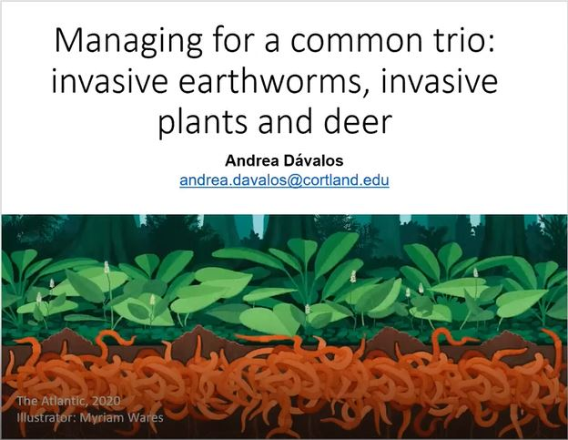Attendance was highest, 38 participants, for the September 28th meeting and presentation on beech leaf disease. Partners Virtual Meetings were recorded and posted on the CRISP website and are available for subsequent viewing: <https://www.catskillinvasives.com/crisp-presentations>

Jessica Newbern, formerly of the National Park Service, resigned as Steering Committee Chair and from the Committee when she left her job and moved from the area. Meredith Taylor stepped in as interim Chair and was elected to serve as Chair for a term beginning in 2022. The CRISP Steering Committee met three times during the year: February 19th, April 18th, and August 25th. The

**Figure 7. Title slides from Andrea Davalos 3/21 presentation at CRISP Partners Meeting Presentation.**

Table 7. CRISP 2021 Steering Committee

| **Name** | **Position** | **Organization** |
| --- | --- | --- |
| Jessica Newbern | Biologist | National Park Service |
| Ethan Angell | Senior Horticulture Inspector | New York State Department of Agriculture and Markets |
| Ian Dunn | Forester 1 | New York State Department of Environmental Conservation |
| Kris Gilbert | Senior Landscape Architect | New York State Department of Transportation |
| John McNaught | Forest Program Manager | Catskill Forest Association |
| Tom Pavlesich | Forestry Program Manager | Watershed Agricultural Council |
| Jeff Senterman | Executive Director | Catskill Center for Conservation and Development |
| Catherine Skalda | CSBI Coordinator | Delaware County Soil and Water Conservation District |
| Meredith Taylor | Invasive Species Biologist | New York City Department of Environmental Protection |
| Donna Vogler | Professor of Biology | SUNY Oneonta |
| Connor Young | Environment and Natural Resources Team Leader | Cornell Cooperative Extension of Greene County |
| Chris Zimmerman | Conservation Ecologist | The Nature Conservancy |

The CRISP listserv was used frequently by CRISP staff, New York Invasive Species Research Institute, DEC, and other partners to share information, promote events and share the latest findings on invasive species. The CRISP listserv continues to grow, adding 60 new members in 2021, and now reaches a total of 312 individuals.

The Early Detection Working Group met to update the CRISP Priority Species List. The Education and Outreach Working Group met during the year to plan online programming and prepare for New York State Invasive Species Awareness Week.

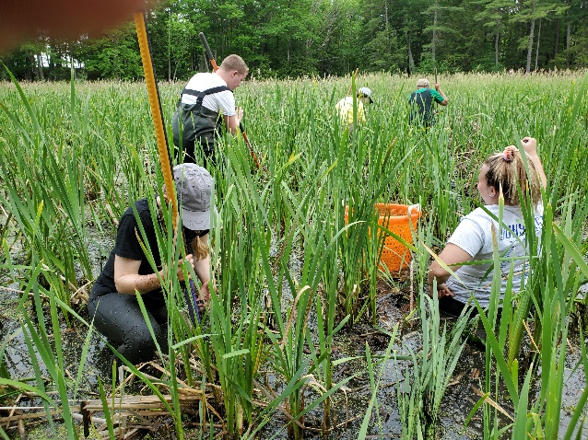Since most of the proposals selected in the 2020 Request for Proposals were not funded in 2020, the Steering Committee decided to work with the organization selected in 2020, but not funded, to try to get the projects going in 2021. In 2020, Catskill Center made the selection of proposals in response to a Request For Proposals (RFP) and Request For Bids (RFB). The selection was made based on a scorecard developed to rank the projects in order of highest priority for funding.

**Figure 8. Otsego County Conservation Association Volunteer Frogbit Pull.**

**Figure 9.CRISP Watershed Steward, Jean Kosina washing pontoon boat at Canadarago Lake.**

The highest priorities for funding included:

1.) **Stop emerging invasive species infestations through Rapid Response**. All proposed control projects must outline project steps as defined in the CRISP Engagement Policy. Eradication and containment projects focused on Tier 2 Species (see CRISP Invasive Species Categorization) are preferred over suppression efforts. Proposals that address species other than Tier 2 Species will be considered, but need justification on the feasibility of containment.

2.) **Surveys for Early Detection Species**. Surveys for Tier 1 or Tier 2 Species beyond what is documented in iMapInvasives and EDDMapS. Surveys for Tier 1 Species; in areas where an introduction pathway exists. A survey methodology will be defined to determine Highly Probable Areas that could support target species.

3.) **Raise public awareness of Tier 1 Early Detection/Prevention Species** to address introduction pathways of forest pests, pathogens or species approaching the region. Programs that focus on Prevention or Early Detection, or have broad application, will be preferred.

4.) **Improve the scientific understanding of the extent, ecological impact, and effective controls of invasive species in the CRISP region**.

5.) **Develop or enhance a structured Community Science Program** that engages and retains participants. A program that trains volunteers to become community scientists collecting significant information on invasive species, offers levels of training and recognition for participants are preferred.

Based on previous agreements and on the ranking by the subcommittee, the following projects were selected for funding:

* Canadarago Lake Improvement Association, “Aquatic Invasive Species Prevention Program”
* Cornell Cooperative Extension Columbia-Greene, “CRISP Education and Outreach”
* Matty’s Landscaping, for maintenance of Hemlock Insectary and Native Planting at Thorn Preserve
* Otsego County Conservation Association, “Greater Otsego County Aquatic Invasive Species and Japanese Angelica Tree Response”
* SUNY Oneonta, “CRISP Watershed Stewards Program”
* Trampoline Advertising and Design Company – new CRISP logo

Due to COVID budget constraints, only two projects were ultimately funded: Canadarago Lake Improvement Association and SUNY Oneonta for Watershed Stewards Programs.

CRISP staff began Ashokan Rail Trail invasive species management planning with a group of invited rail trail stakeholders on February 26. Twelve participants discussed the attributes of the 11.5 mile trail and goals for invasive species management on the site. Vistas were identified as a culturally significant asset and it is important to keep vistas open along the trail. It is a priority to control invasive trees, vines, and tall shrubs (tree-of-heaven, Asiatic bittersweet) that may obstruct vistas. The group also highlighted the need to control Japanese barberry to minimize tick habitat. Volunteer coordination and training were highlighted as important needs to carry out this project. Due to the onset of the COVID pandemic, subsequent public meetings were canceled and the budget for the project was put on hold.

To be consistent with the work of the New York State PRISM network to create cohesive branding throughout the New York State invasive species management network, CRISP began working to update its logo in 2021. A subcontract was developed with Trampoline Advertising and Design Company, located in Glens Falls. A working group was formed to work with Trampoline to develop the logo: John Thompson, Catherine Skalda (Delaware County Soil and Water Conservation District, Catskill Streams Buffer Initiative Coordinator), Marc Wolf (Mountain Top Arboretum, Executive Director), and Allison Dunne (Catskill Center, Communications Manager). The new CRISP logo will feature a fire tower, mountains, hemlocks by a stream, and supporting hands holding up the landscape:

The new logo and branding materials will be rolled out in 2022.